**Goldman Sachs Assessment Questions**

1. **Question:**

**Solution:**

public static int differentTeams(String skills) {

int countOfTeams = 0;

Map<Character, Integer> map = new HashMap<>();

map.put('p',0);

map.put('c',0);

map.put('m',0);

map.put('b',0);

map.put('z',0);

for(int i=0; i<skills.length(); i++) {

char ch = skills.charAt(i);

map.put(ch, (map.get(ch)+1));

}

countOfTeams = Integer.MAX_VALUE;

for (Character key : map.keySet()) {

int value = map.get(key);

if (value < countOfTeams) {

countOfTeams = value;

}

}

return countOfTeams;

}

1. **Question:**

**Solution:**

public static int pointsBelong(int x1, int y1, int x2, int y2, int x3, int y3, int xp, int yp, int xq, int yq){

double ab = Math.sqrt((y2 - y1) * (y2 - y1) + (x2 - x1) * (x2 - x1));

double bc = Math.sqrt((y3 - y2) * (y3- y2) + (x3 - x2) * (x3 - x2));

double ac=Math.sqrt((y3 - y1) * (y3 - y1) + (x3 - x1) * (x3 - x1));

double[] numbers = {ab,bc,ac};

Arrays.sort(numbers);

if((numbers[0]+numbers[1]<=numbers[2])){

return 0;

}

/* Calculate area of triangle ABC */

double A = area (x1, y1, x2, y2, x3, y3);

/* Calculate area of triangle PBC */

double A1 = area (xp, yp, x2, y2, x3, y3);

/* Calculate area of triangle PAC */

double A2 = area (x1, y1, xp, yp, x3, y3);

/* Calculate area of triangle PAB */

double A3 = area (x1, y1, x2, y2, xp, yp);

/* Calculate area of triangle PBC */

double B1 = area (xq, yq, x2, y2, x3, y3);

/* Calculate area of triangle PAC */

double B2 = area (x1, y1, xq, yq, x3, y3);

/* Calculate area of triangle PAB */

double B3 = area (x1, y1, x2, y2, xq, yq);

boolean p = (A == A1 + A2 + A3);

boolean q = (A == B1+B2+B3);

/* Check if sum of A1, A2 and A3 is same as A */

if(p && !q)

return 1;

else if(!p && q)

return 2;

else if(p&&q)

return 3;

else

return 4;

}

public static double area(int x1, int y1, int x2, int y2, int x3, int y3)

{

return Math.abs((x1*(y2-y3) + x2*(y3-y1)+ x3*(y1-y2))/2.0);

}

1. **Problem**Graphical user interface, website

   Description automatically generated

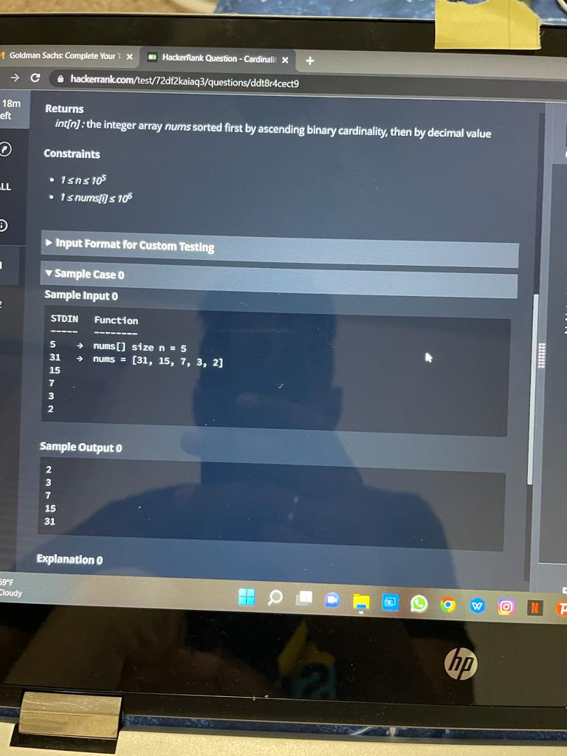

1. **Problem:**

